21BDS0340

Abhinav Dinesh Srivatsa

Foundations of Data Science

Digital Assignment – II

The data for the following visualisation is taken from:

<https://www.kaggle.com/datasets/aungpyaeap/supermarket-sales>

The following visualisation is the gross income from each branch. We can see that C has the most sales, followed by A and B being almost equal.

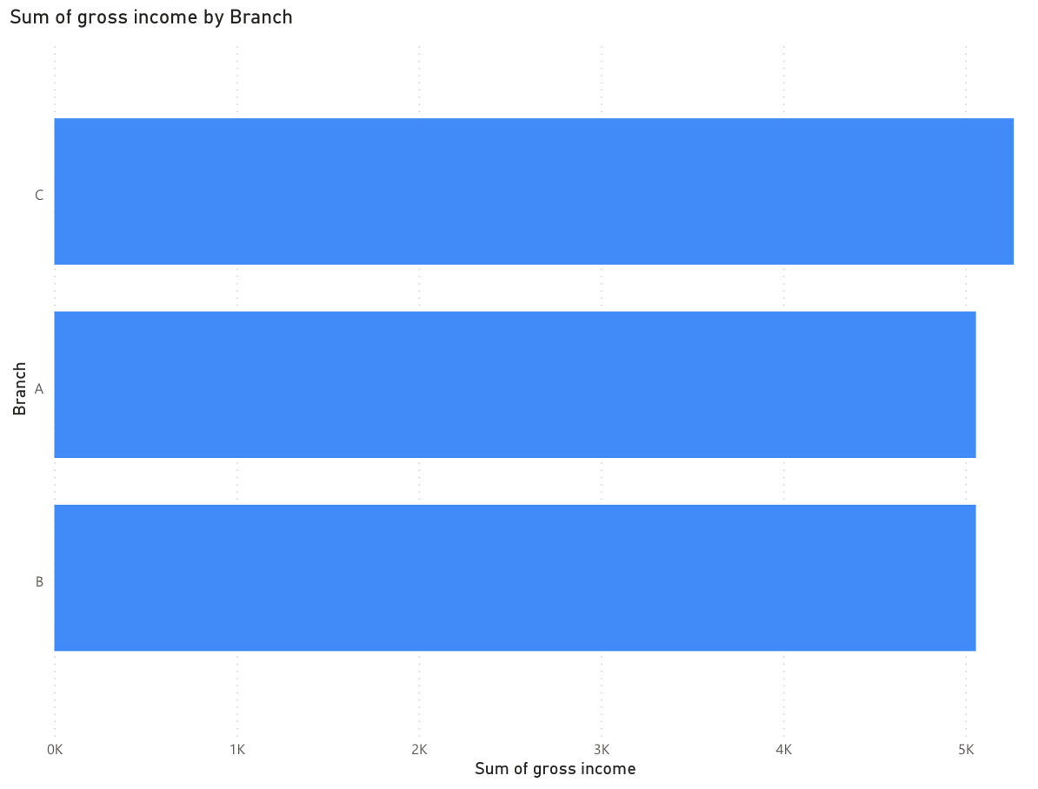

The following is the city distribution of the data, we can see that they are cities from Myanmar.

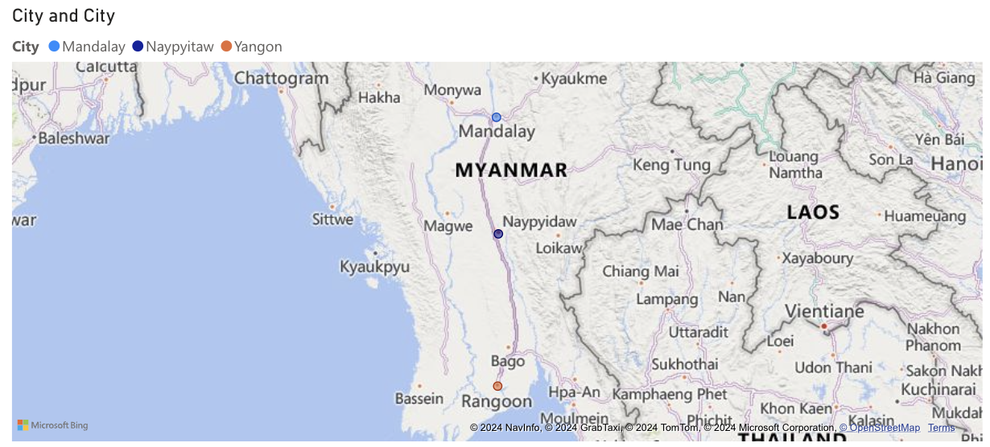

The following is a visualisation for member and normal customers for each branch of the supermarket.

The following is a distribution of genders among the member types.

The following is a graph of the sum of the products sold by month:

The following is a graph of the gross income by month:

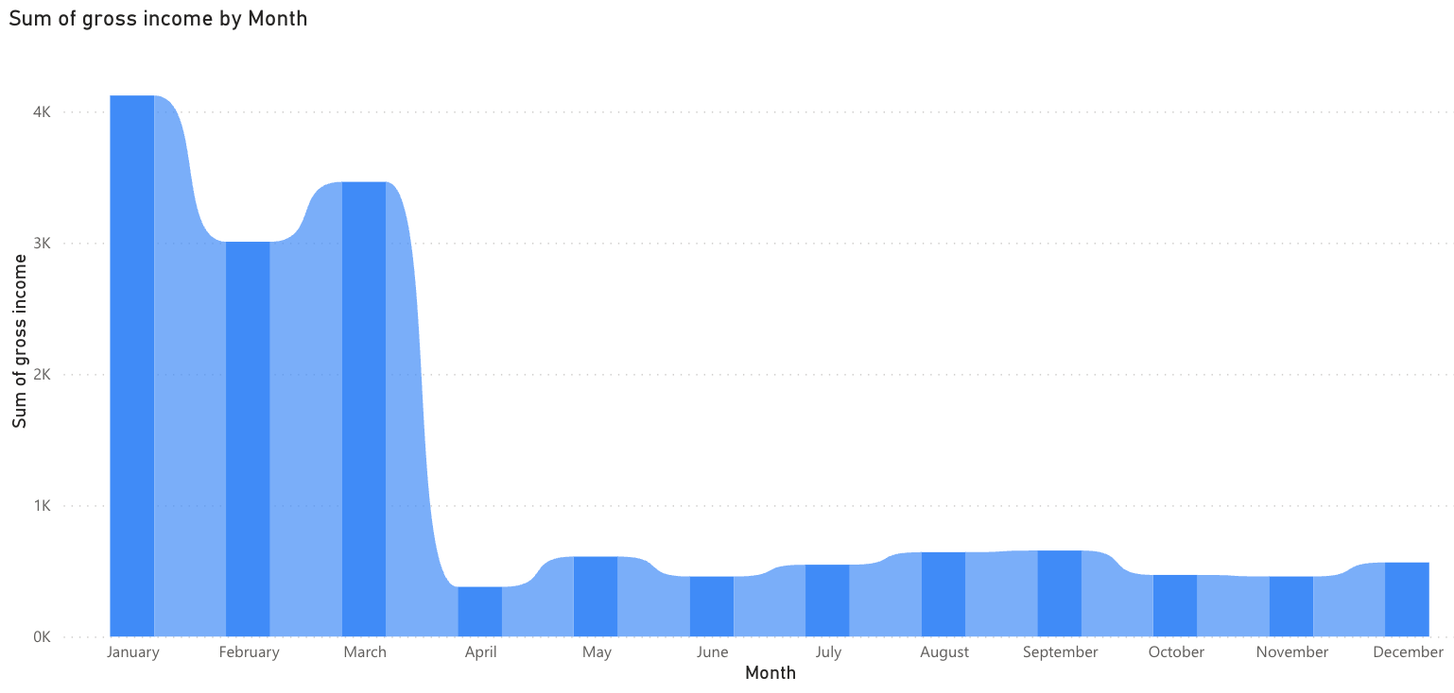

The following is a graph of the category of products sold by month: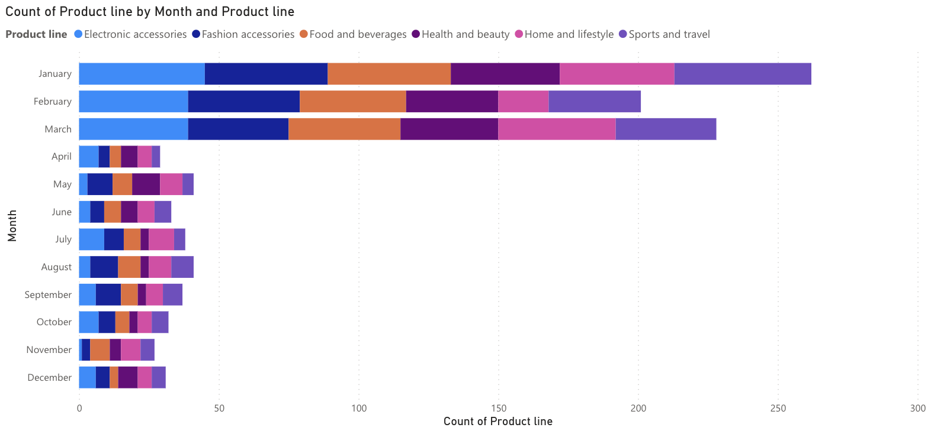

Ratings of products:

